Sergio I Garcia-Rios Govt 3990: Puzzle Solving with Data Cornell University

Application exercise 1.2: Scientific studies in the press
Names:

Write your responses in the spaces provided below. WRITE LEGIBLY and SHOW ALL WORK! Only one submission per team is required. Concise and coherent are best!

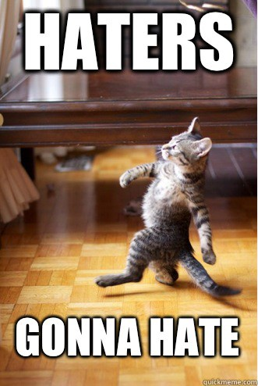
In this activity you will read media coverage of a study published in a peer reviewed journal, and answer a few of question about a study. It is possible that the article doesn’t provide the relevant information to answer certain question(s). If so, refer to the original study (linked below). You do not need to read the entire paper, in fact, you are certainly not expected to understand all of it. Simply find the information that will help you answer the questions.

Media coverage:
Haters Are Gonna Hate, Study Con- firms
By Katy Waldman
Published: August 28, 2013 on Slate Link: http://slate.me/1dr5XPE

Original study:
Hepler, J., & Albarracin, D. (2013). “Attitudes without objects: Evi- dence for a dispositional attitude, its measurement, and its consequences”. Journal of personality and social psychology, 104(6), 1060.
Link: https://sakai.duke.edu/x/ oIukKJ

- What are the cases, i.e. observations?

- What is (are) the response variable(s) in this study?

- What is (are) the explanatory variable(s) in this study?

- Does the study employ random sampling? How about random assignment?

- Is this an observational study or an experiment? Explain your reasoning.

- Can we establish a causal link between the explanatory and response variables?

- Can the results of the study be generalized to the population at large?

